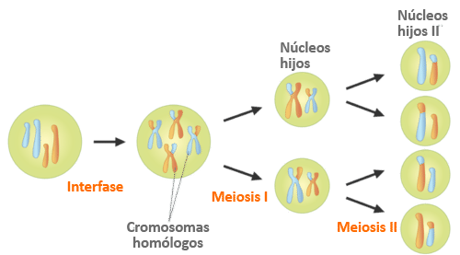

Fuente: <https://dr282zn36sxxg.cloudfront.net/datastreams/f-d%3A07efe7cfe3adcfd3c7fa994a9fd7d335c34f2abf7c69a71562ec196e%2BIMAGE_TINY%2BIMAGE_TINY.1>